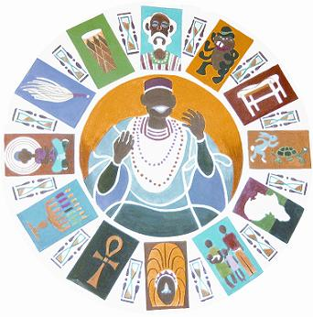
KEEPERS OF THE CULTURE INC.
AFROCENTRIC STORYTELLING GROUP
TELLING OUR STORY, CLAIMING OUR GLORY”

As president of Keepers Of The Culture I offer greetings to the family of Mother Mary Carter-Smith, Members of the National Association Of Black Story Tellers (NABs), and the affiliates of NABs. I did not think about ever having to write a letter as such that I am writing tonight. This letter is about someone whom we all hold dear to our hearts. This letter is about someone who is no longer with us here on earth. This letter is about a Teacher, Poet, Storyteller, and Historian who has achieved a spiritual connection with her “Higher Power.” She has touched each and every one of us with her poetry, stories, and her unique way of communicating through storytelling as an art form, and yes as a teaching method. She is as many have accepted her, an “Ancestor” to always remember and follow her example of life.
I write this letter on the behalf of all Keepers Of The Culture Members (KOTC). We will miss her, but we will not forget her. We will remember her also for being one of the magnificent and creative Founders of NABs along with Sister Linda Goss. Mother Mary and Sister Linda were two strong and dedicated African Women who had a dream that became a vision, a vibrant and positive reality known today as the National Association Of Black Storytellers (NABs).
I want to say that even though I have never had a chance to meet Mother Mary, I have been told so many wonderful things about her over the years, from many KOTC members who have met with her socially and worked with her. I was always told that she was a very beautiful person with a good heart. I also want to say to the family of Mother Mary Carter-Smith, members of NABs, and fellow Affiliate members of NABs, please remember that you have all of our love and support here in Philadelphia from Keepers Of the Culture.

Peace-love-blessings-one moment at a time
Ronald Carter, President
Keepers Of The Culture Inc.
“Telling Our Story, Claiming Our Glory”

